Mark


Northwestern Polytechnical University

Software Engineering Project Report

Title of project
Student Name
Student ID
Submit Date

Directory
Chapter 1 Development plan 1
1.1 Introduction 1
1.1.1 Purpose 1
1.1.2 Scope of Project 1
1.2 Developing tools and environment 1
1.2.1 Hardware 1
1.2.2 Software 1
1.2.3 Other 1
1.3 Project Management 1
1.3.1 Schedule 1
1.3.2 Team Organization and Responsibilities 1
1.4 Software life cycle model 1
1.5 Glossary 1
Chapter 2 Requirement analysis 2
2.1 Introduction 2
2.2 Functional requirements 2
2.2.1 Function1 2
2.2.2 Function2 2
2.2.3 Function3 2
2.3 Nonfunctional requirements 2
2.3.1 Performance requirements 2
2.3.2 Security requirements 2
2.3.3 Other requirements 2
Chapter 3 System and function design 3
3.1 System architecture 3
3.2 Use case diagram 3
3.3 Package/Module diagram 3
3.4 Functional description 3
3.4.1 Function1 3
3.4.2 Function2 3
3.4.3 Function3 3
3.5 Nonfunctional description 3
3.6 Data description 3
Chapter 4 Detail design 4
4.1 Class diagram 4
4.2 ClassA/ModuleA 4
4.2.1 Variable list 4
4.2.2 Function list 4
4.2.3 FunctionA 4
Chapter 5 Programming 5
5.1 Coding rules 5
5.2 Techniques in programming 5
5.3 Difficulties in programming 5
Chapter 6 Testing 6
6.1 Test plan 6
6.1.1 Test environment 6
6.1.2 Test team responsibility 6
6.2 Unit Test 6
6.2.1 Test case 6
6.2.2 Test result 6
6.3 Function Test 6
6.3.1 Test case 6
6.3.2 Test result 6
6.4 System Test 6
6.4.1 Test case 6
6.4.2 Test result 6
6.5 Test Summary 6
Chapter 7 Summary 7
7.1 Project summary 7
7.2 Technical summary 7

1.Remote command line login
2.Save the resource,
3.Security: the messages will be encrypted.

4.Should be used in multiplatform.

/*Template user guide：
This template can be used for documenting a complete software development project.
Please extend or tailor it according to the practical software size or special requirement.
But the following sections marked with “*“must be filled:
Chapter1 Development plan
1.1 Introduction *
1.2 Developing tools and environment*
1.3 Project Management*
1.4 Software life cycle model
1.5 Glossary
Chapter2 Requirement analysis
2.1 Introduction *
2.2 Functional requirements *
2.3 Nonfunctional requirements
Chapter3 System and function design
3.1 System architecture *
3.2 Use case diagram *
3.3 Package/Module diagram
3.4 Functional description *
3.5 Nonfunctional description
3.6 Data description
Chapter4 Detail design
4.1 Class diagram *
4.2 ClassA/ModelA *
Chapter5 Programming
5.1 Coding rules *
5.2 Techniques in programming
5.3 Difficulties in programming
Chapter6 Testing
6.1 Test plan
6.2 Unit test *
6.3 Function test *
6.4 System test
Chapter7 Summary
7.1 Project summary*
7.2 Techniques summary *
*/

Development plan

Introduction

Purpose
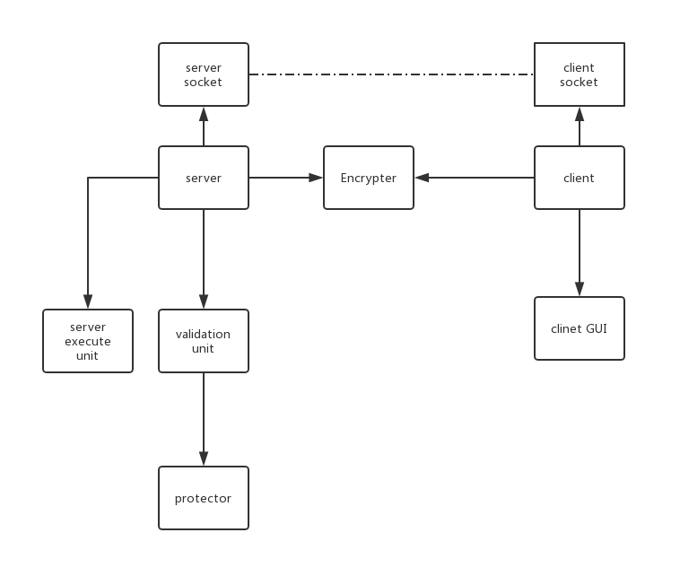
Microsoft terminal services client has some weak points, for example, the limitation of the connection number and the high-cost for the memory and graphic resources.
Thus, we propose a project that covers the core function and avoid such weaknesses.

Scope of Project
Our service include two actors——client and server. You can type the command
and send the instructions to server for execution.

Developing tools and environment

Hardware
Computers

Software
Windows 10
Ubuntu
VMware
Python3

Other
Four smart guys.

Project Management

Schedule
1. Requirement analysis 1 week
2. Functional and detailed design 1 week
3. Code and test prepare 1-2weeks
4.Test and project

Team Organization and Responsibilities

Tshepo 华为(Program and test) GUI part
曹婉豪(Program and test) Validation
黎翔宇（Program and designer）Encrypter
向未来(Leader) Execute

Software life cycle model
waterfall

Glossary
Command line login: It is a service used on the Internet or local area network to provide a bidirectional interactive text-oriented communication facility using a virtual terminal connection.

Requirement analysis

Introduction

Functional requirements

Function1
Bidirectional interactive:
- Send instructions from client to target computer and execute them. Shell process
2. Fetch the feedback from the target computer.

Function2
Support to login one remote computer using several clients.

Function3
Graphic user interface:
save login info
input the command
show the respose
save a log file

Nonfunctional requirements

Performance requirements
Realtime.
This program should receive the response in limit time (about 10 seconds per instruction). If the response failed, the program should disable the connection.
Cost less resource.
The program only provide a command line for each user without the admin right, and each user’s command line is individual with each other. So many command line instance can be live in signal server.

Security requirements
Encrypt and add check bits.
Prevent DDos attack.

Other requirements
The installation should be done in one click.
One PC should be able to run at lest 10 instance.

System and function design

System architecture
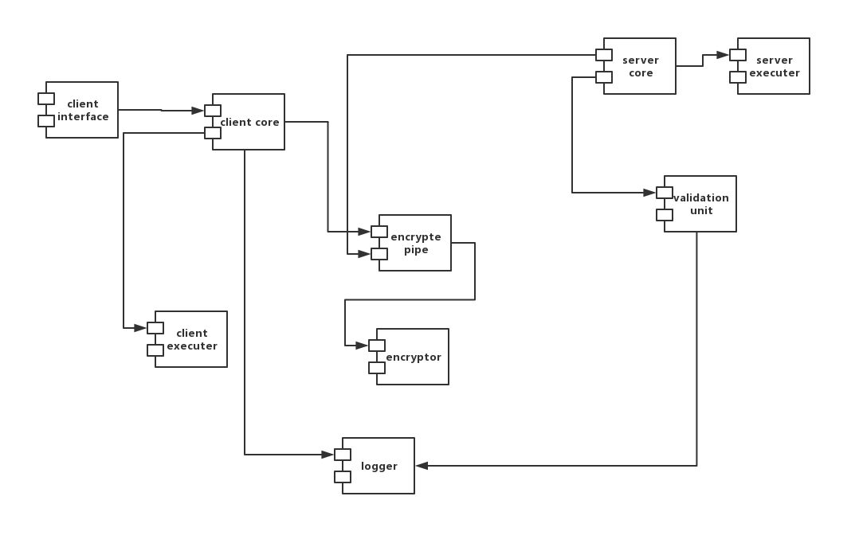

Use case diagram
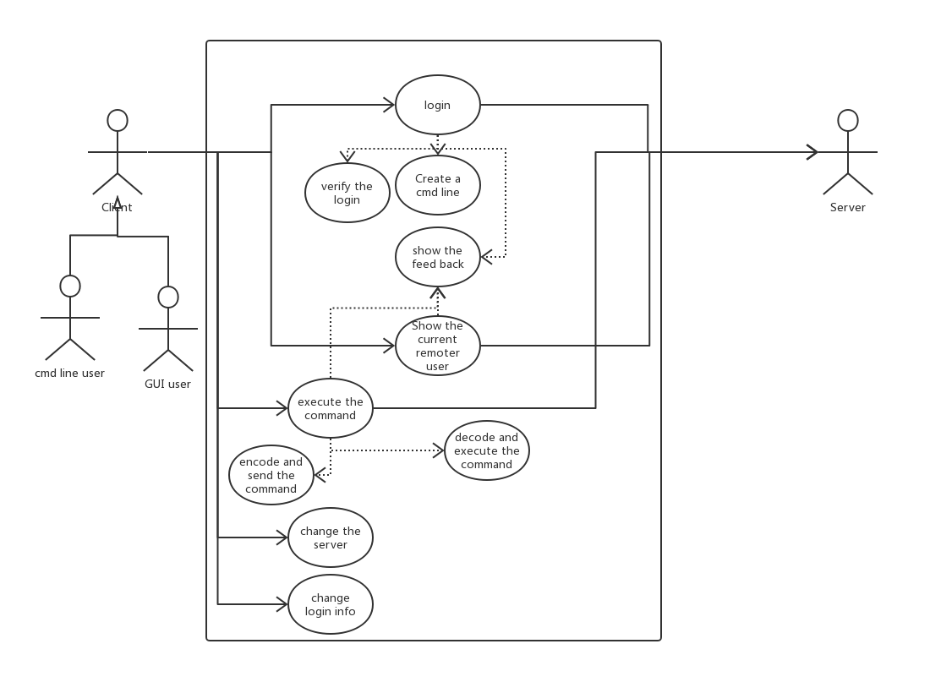

Functional description

Graphical User Interface
- Should allow the user to interact with the remote login utilities.
- Accept the user’s login details and provide them via invoking a port connection trigger function.
- Should allow the user to save his/her login details in order to automatically sign in in future.
- Display status messages such as: ‘Connection established’, ‘Remote device not responding’, etc.
- Display all the clients’ information (id, ip address, etc.) that can be communicated with.
- Should have a logout button that will invoke a connection break.

Execute:
User put a line of instruction in the screen.
Instruction can be any dos command or our special command(such as login)
The client in A’s computer will add A’s login information(without it the server will directly reject the input.) and command type. Then use the encrypte pipe to send the message.
A might also some local instruction, which will not be send to server
The encrypte pipe will do the encrypte & send and receive & decrypt work for client. This unit contains an encryptor.
If the decrypt failed, that means the server and client don’t use the same key. Then they shall exchange it.
The server will receiver the message from encrypte pipe too. It will unpack the message and validate it using validation unit. Then server will execute it or return the error message.
And it will store the log in both server and client.

Nonfunctional description
Encrypt Model:
Encrypt Model contain one method for encrypting and decrypting and integrity checking.
This model will provide 4 function:
1. A encryptor and a decryptor, which can be called by.
2. The encryptor can encrypt byte stream messages and generate a MD5 fingerprint as well.
3. View the key for encryption
4. The decryptor will check if the message is acceptable and decrypt the encrypted a byte stream.
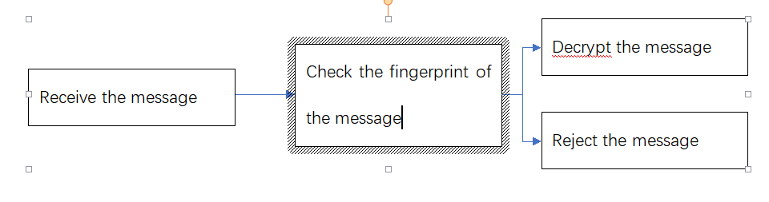
Validation and protector:
A function that enters the account and password to be detected, then reads the legal account and password stored in the text document, and checks whether the entered account and password are legal. If it is illegal, it returns a failure of 1. If it is legal, it detects the input frequency. That is, the number of frequencies defined after the time difference between the input and the last input reaches a certain value is +1, otherwise -1, if the change mutual cross exceeds the threshold, then the failure 2 is returned, and then the frequency is decremented by 1. If none of the above are matched , then return to success.

Data description
Related data format:
Text document setting: one password per line, followed by a password. Separate the space between the account number and the password
Access time and number of related frequencies are defined by the global dictionary
The account and password formats are all strings, the former requirement is the form of the mailbox, and the latter is not required.

Security Key:
A key used to do the encrypt and decrypt.
Instructions used:
Remote ins:
Dos ins: 0x0 execute the dos command
Login:0x1 create a new command line in server
Show the current remote user:0x2 list the current user
End the connection 0x4

Local ins:
Change the remote server 0x0
Add a local user info 0x1
Set the default user 0x2
Add a local user and set to default 0x4
List local users 0x8

Server response table
0x0 execute result.
0x1 login denied.
0x2 need to change key.
0x4 End the connection

Detail design

Class diagram
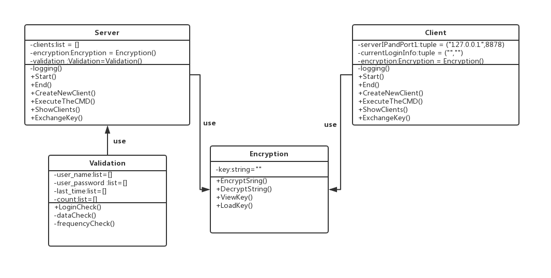

ClassA/ModuleA

Variable list
Important variable definition (meaning, type, value range, default value, etc)
###########
Encryption
###########
-key | The key use to encrypt | string
###########

###########
Validation
###########
-user_name | the list for valid user name | list
-user_password | the list for valid user password | list
-last_time | the list for last execute time for user | list
-count | the count list for user’s | list
###########

###########
Client
###########
-serverIPandPort | The IP address and port for server | tuple(string,int)
-currentLoginInfo | The username and passwoed | tuple(string,st)
-encryption | The encryptor | Encryption
###########

###########
Server
###########
-clients | The active clients | List
-encryption | The encryptor | Encryption
-validation | The validate unit | Validation
###########

Function list
Function name, meaning, parameter data type, return value
###########
validation
###########
+LoginCheck() | input the account and passward,return whether it is legal | String,String | bool
-dataCheck() | input the account and passward,check whether the account is registered and the passward is true | String,String | bool
-frequencyCheck | input the valid account ,check time_intervel and update the count,then return whether the count can be bared | String | bool
###########
###########
Encryption
###########
+ViewKey() | funtion can return the key string of the Encryption instance | None |string
+LoadKey() | can load key from outside into the instance | string | None
+EncryptString() | encrypt a string with the key in the instance | string | string
+DecryptString() | decrypt a string with the key in the instance | string | string
###########

###########
Client
###########
+Start() | Inititalize the client part | None | None
+End() | End the Connection | None | None
+Login() | Do the login. Return 1 if succeed. The negative value will show the error type | None | int
+ExecuteTheCMD() | Execute the command | string | string
+ShowClients() | Show the clients connected to server. Return list of clients. None when failed| None | List
+ExchangeKey() | Exchange key from current server. Return 1 if succeed | None | int
+AddNewAccount() | Add a new local account | (string,string) | int
+SetAccount() | Set the current account to some account | string | int
+AddAndSet() | Add a new account and set it to default | string | int
-logging() | write the log file | string | int
###########

###########
Server
###########
+Start() | Inititalize the server part | None | None
+End() | End the Connection | (string,int) | None
+CreateNewClient() | Create a new client for some user | (string,int) | int
+ExecuteTheCMD() | Run the command | string | string
+ShowClients() | Show the Client list | None | List
+ExchangeKey() | Exchange key from current server. Return 1 if succeed | None | int
-logging() | write the log file | string | int
###########

FunctionA

Client side(sending only)
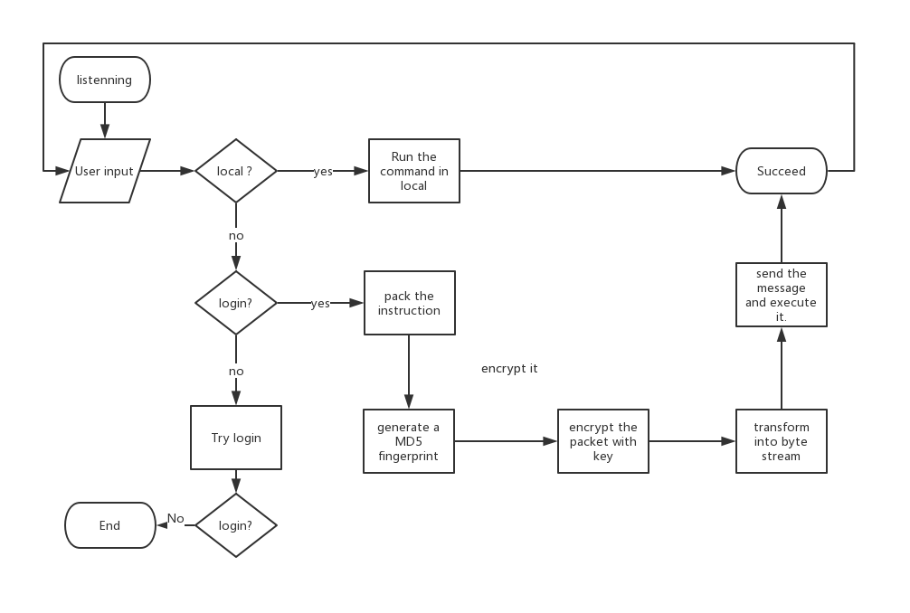

Server side(receive only)
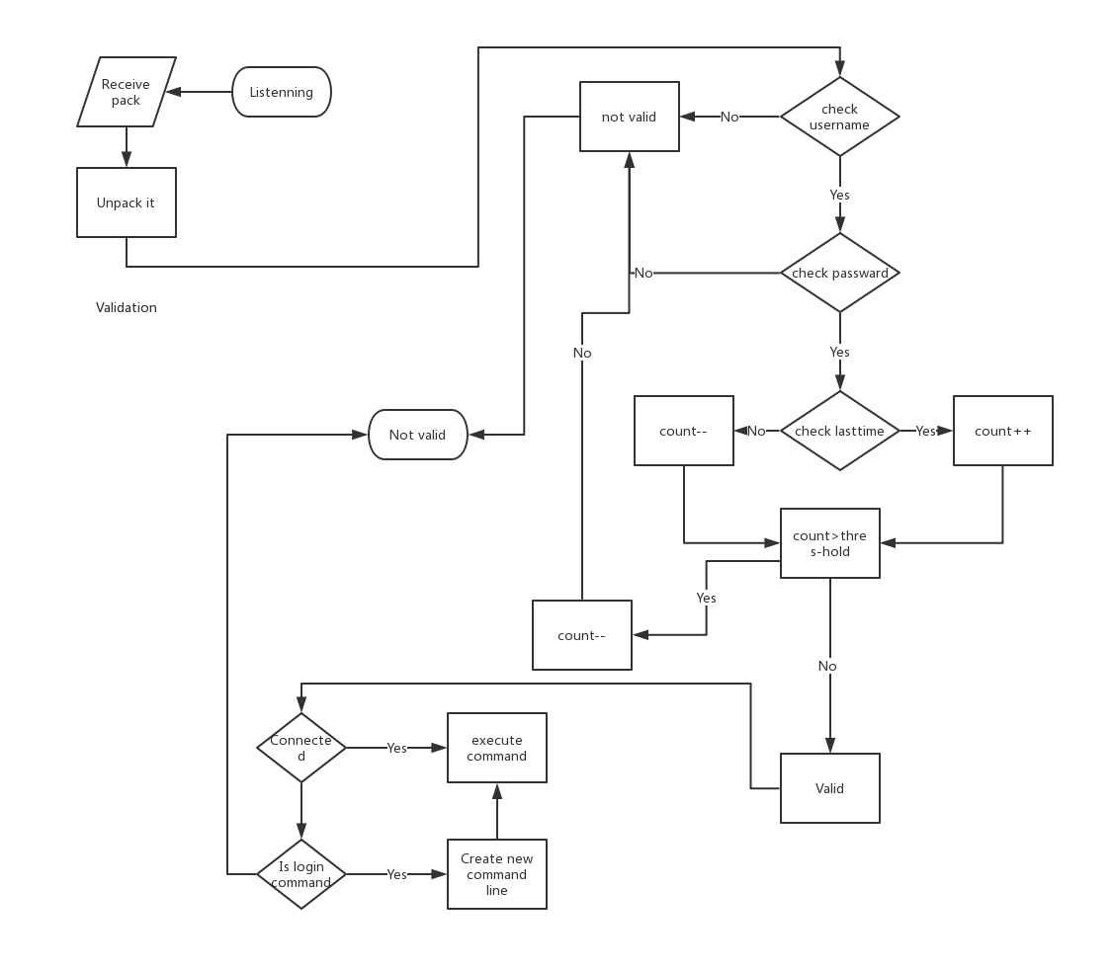

Programming

Coding rules
The main part is two classes: CServer and CClient. So we use the composite model and CS model to build the project. The interact of components is like:
The function of these parts ate:
Server/client socket: build the TCP connection and provide a non-block response.
Encrypter: provide a interface to encrypt the messages from string to bytes
Server execute unit: execute the different user’s command in different cmd context.
Validation: check whether one command from the client has the right to execute
Server: manage the server resources
Client: read the user input and make the connections

With the figure above, every coding members can easily find their job and just finish their component.

Techniques in programming
We code it in python with the help of building packets threading and subprocess.

Difficulties in programming
Some of the member don’t use python before

Testing

Test plan

Test environment
Windows 10 with python 3.6

Test team responsibility
Test the basic function of the program and report the bugs.

Unit Test
See in attachment

Function Test
See in attachment

Summary

Project summary
In this project we develop a connection software used to run commands in remote server. This project has two different parts, server and client part. The server part should be run at the remove server you want to access, and use client to access it. It provide some more functions, such as individual user name and password configuration and arrange functions like “show” command, compared to telnet, and support a light weight log in without graphic interface, compare to mstsc and team viewer.

Technical summary
In this project, we use TCP socket to do the interact and threading to manage the listening thread and provide non-blocked response.

Reference

